**东曲2号原煤模型构建及热解模拟生成甲烷机理表征**

李耀高，王传格，曾凡桂，范晶

(太原理工大学地球科学与工程系,煤科学与技术教育部及山西省重点试验室,太原 030024)

**摘 要：**应用13C-NMR试验数据提取煤大分子的骨架信息，构建东曲2号原煤大分子结构模型，对大分子结构模型分别进行了单个和5个大分子热解模拟，模拟结束后结合动力学参数对热解模拟进行分析。结果表明：在单个大分子模拟中，键长与键级影响着化学反应环境，为模型中C-C断裂的主要因素；在5个大分子组成的分子团模拟中，甲烷生成的反应类型主要有3种：(1)系统模拟稳定升温前，系统能量急剧增大，使处于分子团边缘的C原子与主链裂解脱落；(2)系统稳定升温中期(<2600K)，与分子团热解片段上的芳香核相连的苯甲基脱落；(3)系统稳定升温后期(>2600K)，分子团主链片段上环戊烷受热断开，致使支链末端的甲基脱落生成甲烷。同时通过热解试验来分析甲烷的生成与热解模拟进行对比，从微观角度对煤的热解反应提供理论支撑。

**关键词：**东曲2号煤；煤大分子；ReaxFF反应力场；热解模拟；甲烷

**中图分类号： 文献标识码**：

**The Construction of No. 2 Dongqu Raw Coal Model and Characterization of** **Methane Formation by Pyrolysis Simulation**

LI Yao-gao, WANG Chuan-ge, ZENG Fan-gui, FAN Jing

(*Key Laboratory of Coal Science & Technology of Ministry of Education & Shanxi Province, Department of Earth Science &Engineering, Taiyuan University of Technology, Taiyuan 030024, P. R. China*)

**Abstract:** In this paper, the authors firstly constructed macromolecular structure model of No.2 Dongqu raw coal by extracting the skeleton information of coal macromolecules based on experimental data 13C-NMR, then conducted single macromolecule pyrolysis simulation and five- macromolecule pyrolysis simulation respectively for the macromolecular structure model, and finally analyzed the pyrolysis simulation by combining kinetic parameters after the simulation. It turned out that in the single macromolecular simulation, bond length and bond order affect the chemical reaction environment, mainly causing the fracture of C-C in the model, while in the five-macromolecule pyrolysis simulation, there are three reaction types for the formation of methane: (1) before the chemical system temperature rise steadily, the energy increases sharply, facilitating atom C at the edge of the molecular group is cleaved off the main chain; (2) in the medium term when the chemical system temperature rise steadily(<2600K), benzyl group connected to the aromatic nucleus on the pyrolysis fragment of the molecular group is cleaved off; (3)in the later term when the chemical system temperature rise steadily(>2600K), the cyclopentane on the main chain fragment of the molecular group is thermally broken so that the methyl group at the end of the branch falls off, giving rise to the formation of methane. At the same time, the pyrolysis experiment has been made to analyze the formation of methane and the comparison of methane formation curve between the two pyrolysis processes has also been made, which provides theoretical support for the pyrolytic reaction of coal from the microscopic point of view.

**Key words:** No.2 Dongqu Coal, Coal Macromolecule, ReaxFF, Pyrolysis Simulation, Methane

煤的热解是煤清洁、气化、液化等热转化加工中的重要步骤，研究煤的热解对煤工业生产的意义重大。关于煤结构模型的构建早有研究，1942年宾夕法尼亚大学的Fuchs[1]构建了第一个煤结构模型后，为各学者研究煤结构奠定了坚实的基础。随着测试技术与测试理论，计算机技术的发展，人们对工业分析、元素分析、傅里叶变换红外线光谱(FTIR)、X射线光电子能谱(XPS)等表征煤结构的数据更加准确可信，也可以根据科学计算软件来进行必要的验证计算。Hatcher[2]、贾建波[3]、相建华[4-5]、Wu Li[6]、Zhan-Ku Li[7]、马延平[8]由FTIR、XPS、13CNMR测试数据，结合煤大分子结构模型的理论相继构建了越来越可靠的煤大分子结构模型，为煤的热解模拟、吸附模拟提供了理论模型基础。在煤的热解方面，曾凡桂[9]使用热重-质谱联用技术对低阶煤进行热解模拟试验，从而获得了甲烷的生成速率曲线，使用量子化学理论计算得到甲烷的4种生成反应类型，此为在量子化学角度分析煤热解的主要研究方法；李美芬[10]同样采用热重-质谱联用技术对7种低变质程度煤进行热解模拟试验，研究了其热解特征与第一次煤化作用跃变的关系，其中氢气生成的特征温度参数以及动力学参数可以在甲烷生成的参数分析中提供借鉴意义；Feng Han[11]研究了中国西南地区云南省五种褐煤的热分解和析出气体特性，其中官能团对褐煤失重和气相产物演化有显著影响，其关于低温热解的理论不仅对CO2、CO、H2O适用，也可以推广到煤的其他热解产物中；A. Arenillas[12]研究了在草酸钙为基准的优化系统中，无烟煤和三种不同挥发分含量的烟煤的热解行为，描述挥发性有机化合物的瞬时演化过程，得到煤阶变化对不同官能团含量具有依赖性的结论；Mingjie Gao[13]采用ReaxFF MD进行了超级煤大分子热解模拟，揭示了在煤大分子热解过程中甲烷等气体早期生成的主要反应与羧基和甲氧基密切相关的基本规律；Dikun Hong[14]采用同样的方法对准东煤进行热解模拟揭示了焦油的二次反应机理，为热解模拟提供了新的理论支撑。前人的工作主要是分析煤的热解试验或者煤大分子的热解模拟试验单个方面，为此我们尝试把煤大分子的热解模拟试验与煤的热解试验相结合，对其主要产物甲烷进行分析，在二者之间寻找一定的对应关系。

Since the pyrolysis of coal is an important step in the thermal transition process of coal, including coal cleaning, gasification, liquefaction, etc., it is of great significance to study coal pyrolysis for the production of coal industry. The study on the construction of coal structure model can be traced back to many years ago. In 1942, Fuchs[1] from University of Pennsylvania constructed the first coal structure model, laying the solid foundation for scholars' study on coal structure. With the development of measuring technique and computer technology, people have not only been convinced of the accuracy of the data showed by proximate analysis, ultimate analysis, Fourier Transform Infrared Spectroscopy (FTIR), X-ray Photoelectron Spectroscopy (XPS) and others on coal structure, but they verified the results by use of scientific computing software. Hatcher [2], JIA Jian-bo[3], Xiang Jian-hua[4-5], Wu Li[6],LI Zhan-Ku [7], MA Yan-ping[8], , have successively constructed an increasingly reliable coal macromolecular structure model by combining with the theoretical knowledge of coal macromolecule structural model and using experimental data from FTIR, XPS, 13CNMR, which provides a theoretical model basis for coal pyrolysis simulation and adsorption simulation. As to coal pyrolysis, ZENG Fan-gui[9] has employed the technology of Thermogravimetry-mass Spectrometry to perform pyrolysis simulation experiments on low rank coals and drew the curve graph on methane formation rate, and also applied theoretical knowledge of quantum chemistry to make calculation, recognizing four types of methane formation reactions, which is the main research method for analyzing coal pyrolysis from the perspective of quantum chemistry; LI Mei-fen[10] as well utilized the technology of Thermogravimetry-mass Spectrometry to make pyrolysis simulation experiment on seven low metamorphic coals, and studied the relationship between pyrolysis characteristics and the first coalification jump. In the process, characteristic temperature parameters and Kinetic parameters for hydrogen production can provide reference for parameter analysis of methane formation; Feng Han[11] has explored the features of thermal decomposition and gas precipitation of five lignites from Yunnan Province in southwestern China, finding that functional groups have a significant effect on weight loss of lignite and the evolution of gaseous product. Its theoretical knowledge of low temperature pyrolysis is applicable not only for the generation of CO2, CO, H2O, but other pyrolysis products of coal; A. Arenillas[12] has studied pyrolysis behavior of anthracite and bituminous coal with three different volatile matters in the calcium oxalate-based optimization system, and described the transient evolution process of volatile organic compounds, coming to the conclusion that changes of coal rank were dependent on different functional group contents. GAO Ming-jie [13] carried out pyrolysis simulation on super coal macromolecular by use of ReaxFF MD, revealing the basic law that the main reaction of formation of gases like methane in early stage in the pyrolysis process of coal macromolecular is closely related to carboxyl and methoxy groups; HONG Di-kun[14] has performed pyrolysis simulation on Zhundong Coal by using the same method and revealed secondary reaction mechanism of tar, which provides a new theoretical support for pyrolysis simulation. The predecessors have mainly analyzed coal pyrolysis test or pyrolysis simulation test of coal macromolecules individually, thus we try to combine the two and analyze its main product, methane so as to explore the certain corresponding relationship between the two.

本文构建了东曲2号原煤大分子结构模型，对此模型进行热解模拟分析后，使用热重-质谱联用技术对样品进行热解试验及验证，为煤的热解过程提供更深层次的认识。本次工作基于ADF集成软件中的ReaxFF反应力场，对此模型进行单个大分子的热反应性模拟，模拟终止温度为3000K。在模拟过程中，根据热解过程中不同类型化学键断裂的位置，得到不同温度下侧链官能团键断裂的过程，从微观角度描述煤的热解过程。由于煤以聚集形态[15]存在，热解过程中单个分子的热解会受到其他分子的影响，本次工作同时进行了5个大分子组成的分子团的热反应模拟，终止温度为3000K，分析了分子团热解模拟过程中甲烷生成的反应类型，为煤热解过程中甲烷的来源提供理论依据。除此之外，本次工作还包括使用热重-质谱联用仪(TG/MS)进行热解试验，获得样品热解过程中的失重曲线[16]及甲烷的析出速率曲线[9]，分析二者关系来获得甲烷生成在模拟和试验条件下的关系。

In this paper, authors at first constructed macromolecular structure model of No.2 Dongqu raw coal and conducted.Pyrolysis simulation analysis of this model, and then they made pyrolysis experiment and verification for samples with the technology of thermogravimetry-mass spectrometry, which helped deepen people’s understanding of the pyrolysis process of coal. Based on the ReaxFF in ADF integration software, authors performed heat reactivity simulation of a single macromolecule on the model with a simulated final temperature of 3000K. In the simulation process, according to the position that different types of chemical bond ruptures in the pyrolysis process, how side chain functional bond cleave at different temperatures was clear, and the pyrolysis process of coal was described from a microscopic point of view. Since coal exists in agglomerated form[15], the pyrolysis of single macromolecules would be affected by other molecules. Authors, at the same time, carried out heat reaction simulation of a molecular group consisting of five macromolecules with the final temperature of 3000K, and analyzed reaction type as to methane formation in the process of molecular group pyrolysis simulation, providing theoretical basis for the source of methane in the process of coal pyrolysis. In addition, authors used a thermogravimetric-mass spectrometer (TG/MS) to run pyrolysis experiments, obtaining the weight loss curve[16] and methane precipitation rate curve[9] during the process of pyrolysis of the samples, and analyzed the relationship between the two to explore the relationship between simulated condition and experimental condition where methane was produced.

**1样品与试验**

**1 The Sample and Experiment**

新鲜煤样采自山西太原西山煤田古交矿区东曲2号煤层，对所采东曲2号煤的原煤(镜质组最大反射率为1.81%)进行工业分析、元素分析、13C核磁共振测试。

The fresh coal sample was derived from No. 2 Dongqu coal seam in Gujiao mining area of Xishan Coalfield, Taiyuan, Shanxi, and the collected raw coal (the maximum reflectivity of the vitrinite is 1.81%) was conducted proximate analysis, ultimate analysis, 13C nuclear magnetic resonance test.

工业分析和元素分析(表1)：测试采用德国ELEKRTO-AUTOMATIK公司Vario EL型元素分析仪，测试时在干燥环境下称量20.2g样品，工业分析测定依据国家标准《煤的工业分析方法》(GB/T212-2008)，元素分析测定依据国家标准《煤中碳和氢的测定方法》(GB/T476-2008)。C、H、N、S的测试值为两次平行样品测试的平均值，O元素含量由差减法计算得到。

Proximate analysis and Ultimate analysis (Table 1): The test was carried out by using Vario EL elemental analyzer of the German company, ELEKRTO-AUTOMATIK. During the test, 20.2g sample was weighed in a dry environment. The determination of proximate analysis is based on national standard,*Proximate Analysis Method for Coal* (GB/T212-2008), and the determination of ultimate analysis is based on national standard *Determination Methods of Carbon and Hydrogen in Coal* (GB/T476-2008). The test values of C, H, N, and S are the average values of two parallel sample tests, and the O element content is calculated by minusing.

表1 东曲2号煤的工业 和元素分析

Table1 Proximate and Ultimate Analysis of No.2 Dongqu coal

|  |  |  |  |  |  |  |  |  |
| --- | --- | --- | --- | --- | --- | --- | --- | --- |
| Proximate analysis w /% | | |  | Ultimate analysis wdaf /% | | | | |
| Mad | Aad | Vdaf |  | C | H | O | N | S |
| 0.71 | 2 | 17.72 |  | 90.31 | 4.66 | 2.91 | 1.56 | 0.57 |

13C核磁共振(13C-NMR)测试：测试采用美国Agilent Technologies公司Varian INOVA300型超导核磁共振仪。测试环境为：采用TOSS 抑制边带的交叉极化(CP)技术，外径为6mm的 ZrO2转子，魔角转速为6 kHz，13C检测核共振频率为76.425 MHz，谱宽为3000 Hz，脉宽为4 μs，采样时间为0. 05 s，循环延迟时间为4 s，扫描6000次，接触时间为5 ms。

13C nuclear magnetic resonance (13C-NMR) test: The test was carried out by using Varian INOVA300 model superconducting nuclear magnetic resonance Spectrometer from American Agilent Technologies. The testing environment is as follows: cross-polarization (CP) technology where TOSS is adopted to suppress sideband, ZrO rotor with an outer diameter of 6mm2, magic angle with rotated speed, 6 kHz,13C detection nuclear resonance frequency, 76.425 MHz, spectral width, 3000 Hz, pulse width, 4 μs, the sampling time, 0. 05 s, cyclic delay time, 4 s, scanning times, 6000, and contact time, 5 ms.

单个煤大分子热解模拟：模拟采用荷兰SCM公司的化学材料计算软件中的ADF/ReaxFF模块[17-21]，先对东曲2号煤大分子结构模型进行加氢处理，选择Velocity Verlet+Berendsen系综，在常温常压条件下模拟得到其最低能量构型，然后在边长5nm·5nm·5nm 的lattice中随机放入1个优化过后的东曲2号煤大分子结构模型，模拟热解前设置模拟步数为400000steps，在常压下模拟升温速率为25K/ps，从297K升温至3000K，时间步长为0.25fs，反应力场为HE.ff，对大分子进行热反应性模拟计算，最终得到模型的分子动力学参数及化学键之间的反应关系。

Single coal macromolecular pyrolysis simulation: ADF/ReaxFF module[17-21] in chemical material calculation software of Dutch SCM company was adopted to hydrotreate the macromolecular structure model of No.2 Dongqu coal, and then Velocity Verlet+Berendsen method was selected to perform a simulation under normal temperature and normal pressure conditions, obtaining its structural model with the lowest energy. In the lattice at side length 5nm·5nm·5nm, an optimized No. 2 Dongqu coal macromolecular structure model was randomly put in, with the set simulation step number, 400,000, before the pyrolysis simulation. Under normal pressure, the simulated heating rate was at 25K/ps, making the temperature get raised from 297K to 3000K, with time step, 0.25fs and reaction field, HE.ff, heat reactivity simulation of the macromolecule was calculated, and finally the molecular dynamics parameters of the model and the reaction relationship between the chemical bonds were obtained.

煤分子团热解模拟：本次热解模拟在单个分子热解模拟的基础上，同样采用Velocity Verlet+Berendsen系综，在边长5nm·5nm·5nm 的lattice中随机放入5个优化过后的东曲2号煤大分子结构模型，对此体系进行能量最低化模拟(图7)，模拟热解前设置模拟步数为400000steps，在常压下模拟升温速率为25K/ps，从297K升温至3000K，时间步长为0.25fs，反应力场为HE.ff，对分子团进行热反应性模拟计算。

Coal molecular group pyrolysis simulation: Based on single molecular pyrolysis simulation, Velocity Verlet+Berendsen method was also used. Then 5 optimized No.2 Dongqu coal macromolecular structure model were randomly put in the lattice at side length, 5nm·5nm·5nm, and the energy minimization simulation (Fig. 7) for this system was run, with the set simulated step number, 400,000 before the simulation pyrolysis. Under normal pressure, the simulated heating rate was 25K/ps, facilitating the temperature to raise from 297K to 3000K, with the time step, 0.25fs and the reaction field, HE.ff, heat reactivity simulation calculation of the molecular group was performed.

TG/MS试验：热解试验所用仪器为德国NETZSCH公司型号为STA449 F3-QMS403 D的热分析-四级杆质谱仪，热重试验在干燥环境下进行，称重东曲2号原煤样品10mg，仪器在真空的条件从313K升温至1273K，升温速率为10K/min，试验气氛为氮气，吹扫气流速为80 mL/min，保护气流速为20mL/min，仪器可测气体产物质量范围为1u-300u。

TG/MS experiment: The instrument of thermal analysis-quadrupole mass spectrometer, the type 447Z F3-QMS403 D from Germany company NETZSCH, was used in the pyrolysis experiment. The thermogravimetric experiment was carried out in a dry environment, and 10 mg No.2 Dongqu raw coal sample was weighed. Under vacuum condition, the temperature of the instrument got raised from 313K to 1273K, with the heating rate, 10K/min. With experiment atmosphere, nitrogen, the purge gas flow rate, 80 mL/min, and shielding gas flow rate, 20mL/min, the instrument could measure the gas product quality at a range of 1u-300u.

**2模型构建及试验分析**

**2.1 东曲2号煤的模型构建及修正**

**2.1.1 模型构建**

**2 Model Construction and Experimental Analysis**

**2.1 Model Construction and Updating of No. 2 Dongqu Coal**

**2.1.1 Model Construction**

对表征煤结构的13C-NMR数据进行解析，参考贾建波[3]、相建华[4-5]等人的煤大分子化学结构模型构建方法，通过模拟结构中芳香结构单元、脂肪结构和其他官能团的连接方式，构建东曲2号原煤的大分子结构模型。

The authors firstly analyzed 13C-NMR data characterizing coal structure, and then constructed the macromolecular structure model of No.2 Dongqu raw coal by simulating connecting aromatic structural units, fat structures and other functional groups in the structure and referring to coal macromolecular chemical structure model construction methods of Jia Jianbo[3]Xiang Jianhua[4-5] and so on.

图1 东曲2号煤13C-NMR 分峰谱图

Fig.1 13C-NMR Peak-differentiating Spectrum of No.2 Dongqu Coal

使用Origin7.5软件对13C-NMR原始谱图进行分峰拟合(图1)。根据各官能团的化学位移及其相对含量，计算东曲2号煤中脂肪碳及芳香碳部分等十二个主要结构参数(表2)。

The software Origin 7.5 is used to conduct peak-differentiating and imitating(Fig. 1) for the original spectrum, 13C-NMR. In addition, the parameters of twelve main structures in No.2 Dongqu coal like fatty carbon and aromatic carbon were calculated (Table 2) based on the chemical shift and the relative content of each functional group.

表2东曲2号煤的结构参数

Table 2 Structure Parameters of No.2 Dongqu Coal

|  |  |  |  |  |  |
| --- | --- | --- | --- | --- | --- |
| Aromatic Carbon | Types of Aromatic Carbon |  | Fatty Carbon | Types of Fatty Carbon |  |
| *fa* (100-220) | Total Carbon | 0.75 | *fal* (-90) | Total Carbon | 0.25 |
| *fa’*(100-165) | Aromatic Carbon | 0.65 | *falH* (-36) | Methylene or Methyne Carbon  Oxygen carbon | 0.10 |
| *faC*(165-) | Carboxyl Carbon | 0.10 | *fal\**(36-50) | Methyne Carbon or | 0.10 |
| *faH*(100-129) | Protonated Aromatic Carbon | 0.44 | *falO*(50-90) | Quaternary Carbon | 0.05 |
| *faN*(129-165) | Nonprotonated Aromatic Carbon | 0.21 |  |  |  |
| *faP*(150-165) | Phenolic Hydroxyl or Ether Oxycarbonization | 0.01 |  |  |  |
| *faS*(135-150) | Alkyl Substituted Carbon | 0.03 |  |  |  |
| *faB*(129-137) | Aromatic Bridge Carbon | 0.17 |  |  |  |

**2.1.2 模型修正**

**2.1.2 Model Updating**

依据东曲2号煤的结构参数，结合分析13C-NMR谱图得到的东曲2号煤芳香桥碳与周碳之比：

According to the structural parameters of No.2 Dongqu coal, authors obtainedthe ratio of aromatic bridge carbon to pericarbon in Dongqu No. 2 coal by analyzing 13C-NMR spectrum:

经计算，通过各个芳香基团的不同组合，得到最接近数值所对应的芳香结构类型及数量(表3)，计算得到东曲2号煤大分子结构模型中的芳香碳个数为117。

Through calculation, , and then by the combination of different aromatic groups, the corresponding types and numbers of aromatic structure which is the closest to the values of in the equation can be obtained(Table 3). Consequently, it is calculated that the number of aromatic carbons in macromolecular structure model of No. 2 Dongqu coal was 117.

由芳香度的定义结合表2计算得到所要构建的大分子模型的芳碳率为0.67，从而计算出东曲2号煤大分子结构模型中碳的个数为174，结合元素分析数据(表1)进行推导，Num(C:H:N:O)= (90.31 / 12):(4.66 / 1):(1.56 / 14):(2.91 / 16)。综上可得东曲2号煤大分子模型的分子式为。

By referring to Table 2, authors, based on the definition of aromaticity, calculated the aromatic carbon ratio of macromolecular model to be constructed: 0.67 and thus worked out the number of carbon in macromolecular structure model of No. 2 Dongqu coal was 174.Then, it is deduced that Num(C:H:N:O)= (90.31 / 12): (4.66 / 1): (1.56 / 14): (2.91 / 16) on the base of ultimate analysis data (Table 1) ). In summary, the molecular formula of No. 2 Dongqu coal macromolecular model is .

表3 东曲2号煤芳香结构类型和数量

Table3 Types and Quantities of Aromatic Structure in No.2 Dongqu Coal

|  |  |  |  |  |  |
| --- | --- | --- | --- | --- | --- |
| Types of Aromatic Structure | | Quantity | Types of Aromatic Structure | | Quantity |
| 33 | 4 Ring | 3 |  | 1 Ring | 1 |
|  | 3 Ring | 2 |  | < 3.0 Å | 1 |
|  | 2 Ring | 2 |  | 1 |

依据上述分析计算得到东曲2号煤大分子结构模型中各种元素的赋存形态及官能团的个数比，使用ACD/CNMR软件构建煤大分子结构模型，由gNMR软件计算每个碳原子的化学位移后，在Origin软件中将预测谱图与试验核磁谱图进行对比，如果二者相差较大，则重复进行结构模型修改、谱图对比的工作，直到试验核磁谱图与预测的13C-NMR谱图匹配吻合(图2)，得到最合适的大分子平均结构模型。在样品元素分析过程中测定氢元素的影响因素多并且复杂，故使用模型中的氢含量作为最终结果，经校正煤大分子的分子式为。东曲2号煤大分子结构模型(图3)通过脂肪碳键或者两芳环直接相连的碳键相连，由一个以芳香环主长链为主要骨架，及三个交联作用较为强烈的侧链组成[3-5, 8, 22-23]。

The above analysis helped obtain occurrence patterns of various elements and calculate the numbers of functional groups and the ratio among them in the macromolecular structure model of No.2 Dongqu coal. Then the software ACD/C NMR was used to construct the coal macromolecular structure model, and software gNMR was used to calculate the chemical shift of each carbon atom so as to make comparison between the predicted spectrum and the experimental nuclear magnetic spectrum in the software Origin. If the difference between the two is large, the modification of structure model and the comparison of spectrogram were continuously being carried out until the experimental nuclear magnetic spectrum and the predicted 13C-NMR spectra were matched(Fig. 2), with the most suitable macromolecular average structure model being gotten. In the process of analyzing sample elements, since the factors affecting the determination of hydrogen are numerous and complex, the hydrogen content in the model was used as the final result. After the correction, the molecular formula of coal macromolecule is . The macromolecular structure model of No.2 Dongqu coal (Fig. 3) is connected by fatty carbon bond or carbon bond directly connected to two aromatic rings, and consists of an aromatic ring main chain, the main skeleton and three side chains with strong cross-linking property[3-5, 8, 22-23].



图2 试验与模拟谱图对比

Fig.2 The Comparison between Experimental Spectrogram and Calculateded Spectrogram

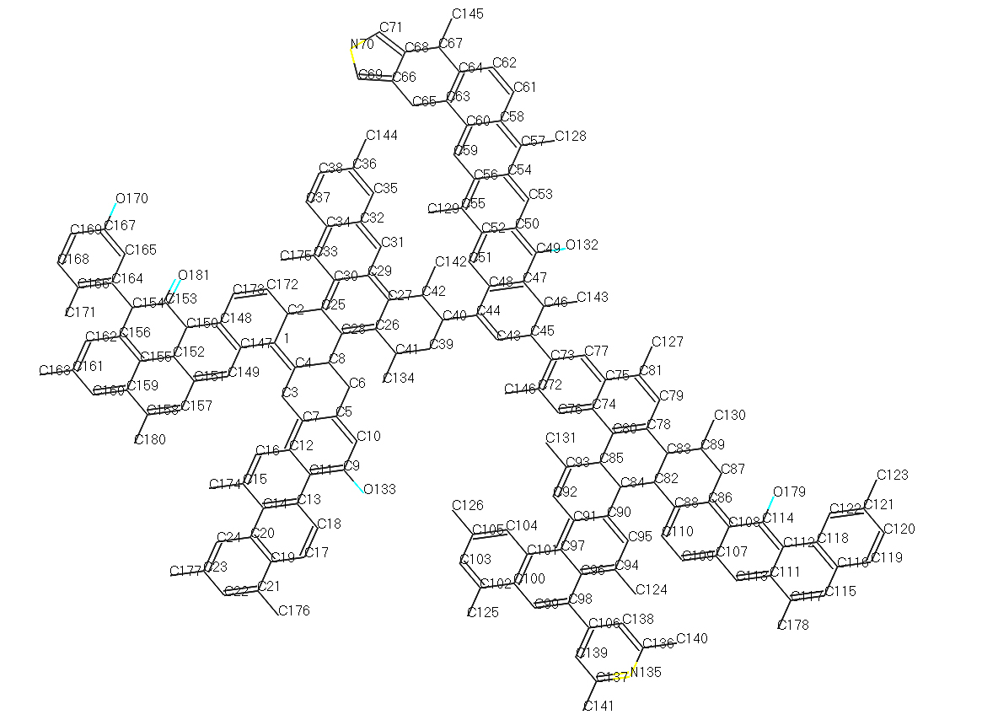

图3 东曲2号煤的大分子模型

Fig.3 Macromolecular Model of No.2 Dongqu Coal

**2.2 东曲2号煤结构模型的热解模拟**

**2.2.1 单个煤大分子热解模拟分析**

**2.2 The Pyrolysis Simulation of No. 2 Dongqu Coal Structure Model**

**2.2.1 The Pyrolysis Simulation Analysis of Single Coal Macromolecular**

单个煤大分子热解模拟过程中计算出最低能量构型(图4)，模拟完成后选取开始和结束两个时间点的能量 (表4)进行对比。

During the pyrolysis simulation of single coal macromolecule, the lowest energy configuration was calculated(Fig. 4). After the simulation, the energy at the start point and the energy at the end point (Table 4) were selected for comparison.

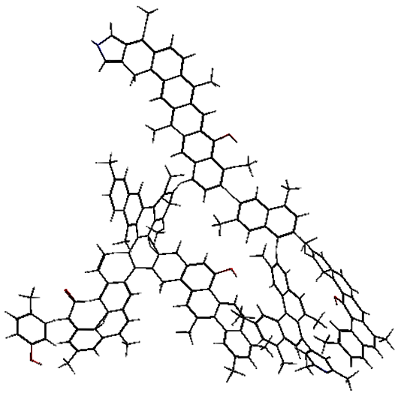

图4 东曲2号煤能量最低构型

Fig.4 Energy- minimum Configuration of No.2 Dongqu Coal

表4 单个分子动力学模拟前后的能量(kcal /mol)对比

Table4 Energy (kcal /mol)Comparison before and after Single Molecular Dynamics

|  |  |  |  |  |  |  |  |
| --- | --- | --- | --- | --- | --- | --- | --- |
| Simulated Condition | Ebond | Eatom | Etors | Evdw | Echarge | Etotal | |
| Start | -62408.01 | 782.27 | 223.29 | 20311.21 | 806.09 | | -36384.39 |
| End | -69678.87 | 960.86 | 191.72 | 16381.67 | 901.39 | | -43087.92 |

从表4可以看出在单个分子动力学模拟前后的总能量由-36384.39 kcal/mol减小为-43087.92kcal/mol，键能由-62408.01kcal/mol减小为-69678.87kcal/mol，系统内部的扭转能和范德华力能都相应减小，造成此现象的原因为热解过程中系统内部产生了各种官能团片段，致使系统的总能量、键能、扭转能、范德华力能都有所减小，而系统的原子能由782.27 kcal/mol增大为960.86kcal/mol，电荷能由806.09 kcal/mol增大为901.39kcal/mol，说明在此系统中程序升温模拟条件下，大分子裂解成碎片后系统的稳定增强。

From Table 4, it is can be seen that the total energy is reduced from -36384.39 kcal/mol to -43087.92 kcal/mol, and that the bond energy is reduced from -62408.01 kcal/mol to -69678.87 kcal/mol after the single molecular dynamics simulation, causing the torsional energy and the energy of van der Waals force were reduced accordingly. The reason for the phenomenon is that various functional group fragments were generated inside the system during the pyrolysis process, resulting in the reduction in total energy, bond energy, torsional energy, and energy of van der Waals force in the system. However, the atomic energy in the system increased from 782.27 kcal/mol to 960.86kcal/mol, and the charge energy increased from 806.09 kcal/mol to 901.39kcal/mol, indicating that the system’s stability got enhanced after macromolecule was splited into fragments in the simulated condition where temperature rose in this system.

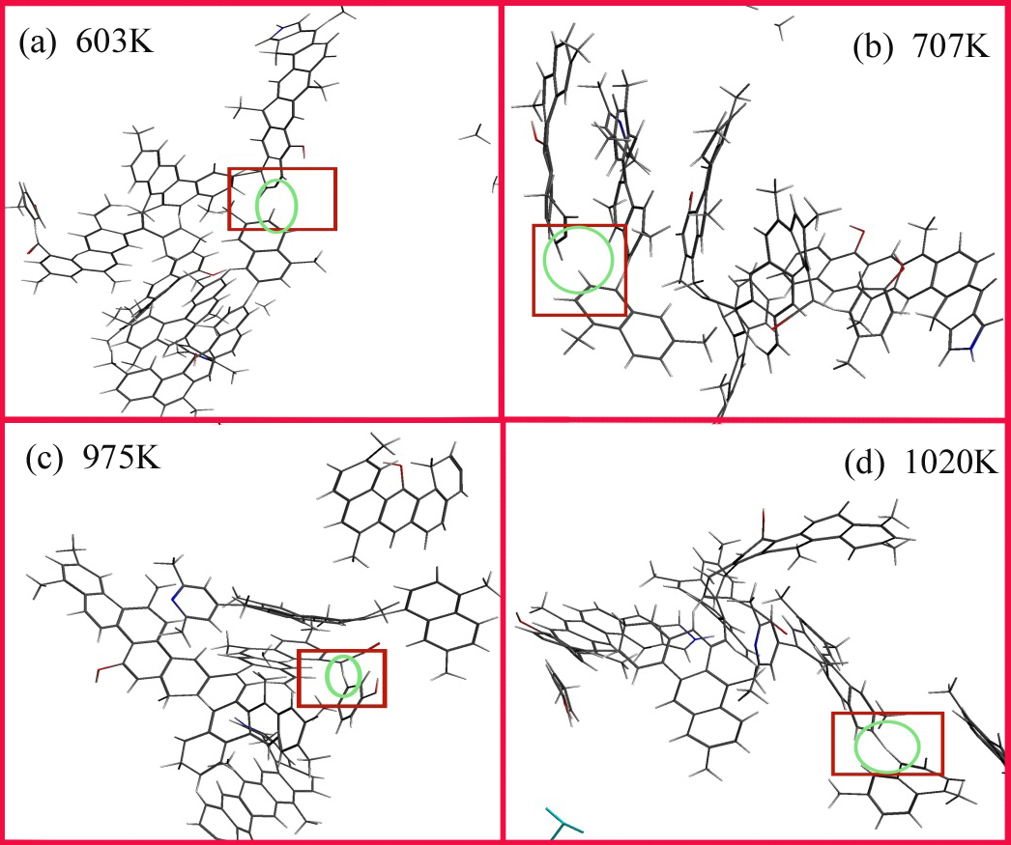

图5 单个大分子热解反应过程

Fig.5 Pyrolysis Process of Single Macromolecule

在lattice中对大分子进行加氢处理，得到最低能量构型后，进行单个大分子的热解反应模拟，反应过程为：第1个大分子片段从主结构上脱落(图5_a)的过程发生在603K左右，此时由于系统内部温度升高，大分子在此化学环境下的总能量升高，大分子结构模型主链上相对活跃的C73-C45键断裂，造成含有N135，O179两个支链的分子片段从主链上脱落，产生了两个大分子片段。

The macromolecule was hydrotreated in the lattice so as to obtain the lowest energy configuration, and pyrolysis reaction simulation of the single macromolecule was conducted. The reaction process was as follows: At around 603K, the first macromolecular fragment was cleaved off from the main structure (Fig. 5_a), and at the same time, the total energy of the macromolecule in this chemical environment increased due to the increase of the temperature inside the system,, so the relatively active C73-C45 bond on the main chain of the macromolecular structure model ruptured, causing molecular fragments containing the two branched chain N135,O179 detached from the main chain, resulting in two macromolecular fragments.

第2个碎片从第1个大分子片段上脱落(图5_b)的过程发生在707K左右，603K时从主链上脱落的大分子片段有两个支链，在此温度下连接两个支链的脂肪碳键C84-C82断裂，致使两个支链的交联作用下降，在此化学环境下相对活跃的C83-C78断裂，造成含有O179的支链从刚刚从主链上脱落的片段上脱落。

The second fragment was detached from the first macromolecular fragment (Fig. 5_b) when the temperature was at about 707K. At 603K, there were two branched chains in the macromolecular fragment detached from the main chain, and the fatty carbon bond C84-C82 connecting the two branched chains ruptured, causing the decrease of cross-linking property. In such chemical environment, the relatively active C83-C78 ruptured, causing the falling of the branched chain containing O179 from the fragment just detached from the main chain.

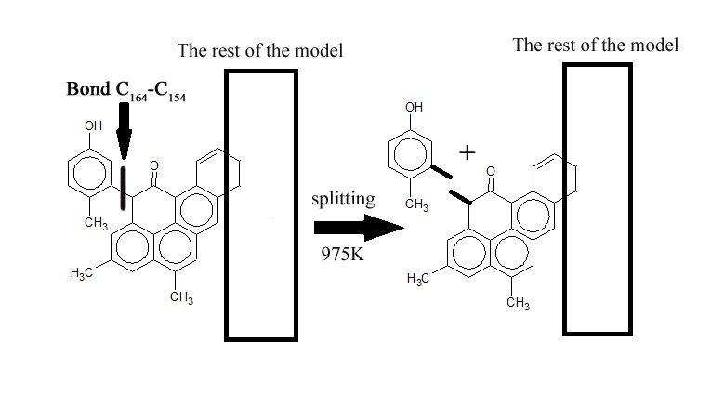

图6 975K时化学反应过程

Fig.6 Chemical reaction process at 975K

第3个碎片从结构上脱落(图5_c)的过程发生在975K左右，在此化学环境下，可能由于O170与O181的作用使周围的C相对活跃，在此时造成C164-C154发生断裂(图6)，生成一个对甲基苯酚。

The third fragment fell off from the structure (Fig. 5_c) when the temperature was around 975K. In the chemical environment, the surrounding C got relatively active due to O170 and O181, causing the rupture of C164-C154 (Fig. 6) and thus the generation of a p-methylphenol.

第4个碎片从主结构上脱落(图5_d)的过程发生在1020K左右，第2个碎片脱落后，C85-C80断裂生成一个分子片段和二甲基萘。由此可见煤热解过程中主键断裂大部分发生在相对低温的环境中(<1100K)。

The fourth fragment fell off from the main structure (Fig. 5_d) when the temperature was around 1020K. After the second fragment fell off, C85-C80 ruptured, producing a molecular fragment and dimethylnaphthalene. It showed that the rupture of the main bond during coal pyrolysis occurs in a relatively low temperature environment (<1100K) mostly.

**2.2.2 煤分子团热解模拟分析**

**2.2.2 The Pyrolysis Simulation Analysis of Coal Molecular Group**

5个煤结构模型分子组成的分子团热解模拟过程中可计算出最低能量构型(图7)，模拟完成后获得甲烷的生成过程及析出速率曲线(图8)，并选取开始和结束两个时间点的能量 (表4)进行对比。

The lowest energy configuration(Fig. 7) was worked out during the pyrolysis simulation process of molecular group consisted of the five coal structure model molecules. After the simulation, the process of methane formation was clear and methane precipitation rate curve were obtained (Fig. 8), and the energy at the start point and that at the end point(Table 4) were selected for comparison.

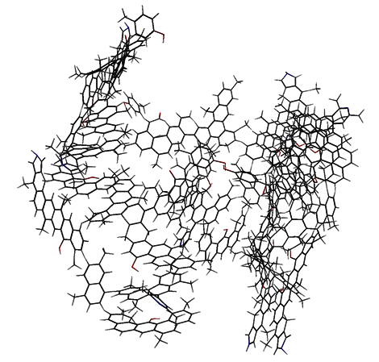

图7分子团能量最低构型

Fig.7 Energy- minimum Configuration of Molecular Group

表5 分子团动力学模拟前后的能量(kcal /mol)对比

Table5 Comparison of Energy (kcal /mol) before and after Molecular Dynamics Simulation

|  |  |  |  |  |  |  |
| --- | --- | --- | --- | --- | --- | --- |
| Simulated Condition | Ebond | Eatom | Etors | Evdw | Echarge | Etotal |
| Start | -298394.73 | 4804.16 | 958.85 | 81883.61 | 4017.62 | -215469.43 |
| End | -298501.77 | 4844.86 | 952.87 | 81839.13 | 4068.73 | -215606.38 |

从表5可以看出在分子团动力学模拟前后的总能量由-215469.43 kcal/mol减小为-215606.38kcal/mol，键能由-298394.73kcal/mol减小为-298501.77kcal/mol，系统内部的扭转能和范德华力能都相应减小，造成此现象的原因为分子团在相应的化学环境下的热解过程中产生了各种官能团片段，致使系统的总能量、键能、扭转能、范德华力能都有所减小，而对应的是系统的原子能和电荷能增加，结果和单个分子动力学模拟前后的各能量变化对应，又符合系统能量守恒的基本原理。

According to Table 5, it can be seen that the total energy was reduced from -215469.43 kcal/mol to -215606.38kcal/mol, and that bond energy was reduced from -298394.73kcal/mol to -298501.77kcal/mol through molecular group dynamics simulation, causing both torsional energy and the energy of van der Waals force were correspondingly reduced. The reason for the phenomenon is that the molecular group generated various functional group fragments in the pyrolysis process under the corresponding chemical environment, resulting in the reduction of of total energy, bond energy, torsion energy and the energy of Van der Waals' force inside the system. However, atomic energy and charge energy inside the system increased. The result corresponded to the energy changes before and after the single molecular dynamics simulation, and it conformed to the basic principle of system energy conservation.



图8 分子团模拟热解过程中甲烷析出速率曲线

Fig.8 Methane Precipitation Rate Curve during the Process of Molecular Group Pyrolysis Simulation



图9分子团模拟热解过程中势能变化曲线

Fig.9 The Potential Energy Changing Curve during the Process of Molecular Group Pyrolysis Simulation

从热解模拟过程中的甲烷的生成速率曲线(图8)可以看出，甲烷自2200K左右开始析出，在 2580K析出速率达到最大，至热解终温3000K基本结束。在热解过程中系统的势能(图9)在模拟开始的瞬间由于力场的作用并且温度迅速变化，导致在NVT系综内的系统能量迅速增大，具体表现为系统的势能迅速增大，较短时间后系统热解反应稳定，系统的势能迅速减小，随后的总体变化趋势为随着时间的变化而增大。

From the methane precipitation rate curve (Fig. 8) in the pyrolysis simulation process, it can be seen that methane starts to precipitate when the temperature is about 2200K, and that the precipitation rate reaches the maximum when it is at 2580K and the rate is close to zero when the final temperature for pyrolysis is 3000K. During the pyrolysis process, the system energy in the method NVT increases rapidly due to the action of the force field and the rapid temperature change at the beginning of the simulation, which drives the potential energy of the system (Fig. 9) rapidly to increase. After a short period of time, the system pyrolysis reaction is stable, and the potential energy of the system decreases rapidly. Then the subsequent overall trend tends to increase as time goes by.

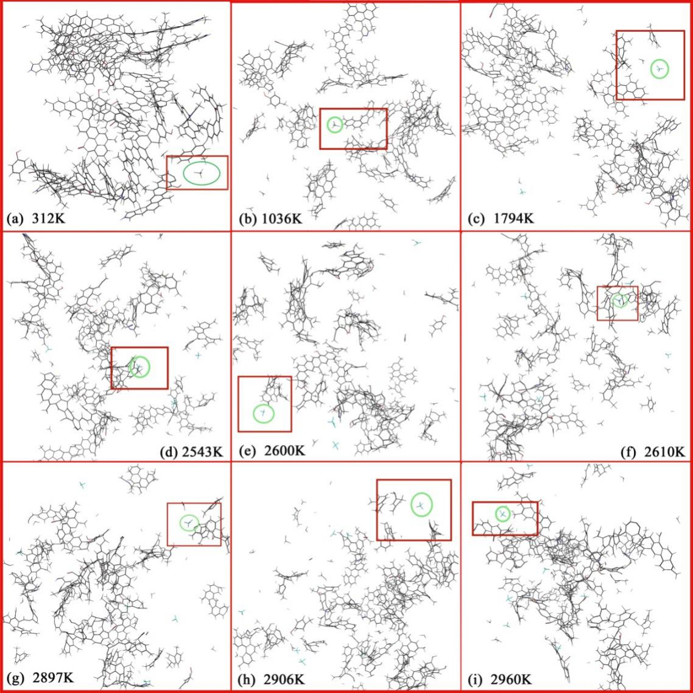

图10 分子团热解反应过程

Fig.10 Description of the pyrolysis process of molecular group

在东曲2号煤大分子结构模型热解模拟过程中，甲烷的生成途径(图10)主要为ReaxFF力场体系中，煤结构的几个主要侧链官能团上甲基的一次或者二次脱落。

In the pyrolysis simulation process of No.2 Dongqu Coal macromolecular structure model, the formation of methane (Fig. 10) is mainly from the primary or secondary detachment of methyl groups on several major side chain functional groups of the coal structure in the force field system, ReaxFF.

在SCM MOVIE中对甲烷的生成方式进行定位追踪，第1个甲烷分子生成(图10_a)在312K左右，来源为C130-C89键的断裂导致C130甲基脱落后与氢离子结合生成甲烷。在模拟过程开始的一瞬间由于系统的势能迅速增大的原因，导致体系内的5个大分子模型组成的分子团受到急剧变化，使处于分子团边缘相对不稳定的C130脱落形成苯甲基生成一个甲烷。

In SCM MOVIE, the method of methane formation was tracked. When it was around 312K, the methyl group C130 was detached due to the breaking of the bond, C130-C89, and combined with hydrogen ions, thus the first methane molecule was formed (Fig. 10_a). At the beginning of the simulation process, the rapid increase of the system's potential energy led to the drastic change of the molecular group composed of the five macromolecular models in the system, so relatively unstable C130 at the edge of the molecular group was detached and formed a benzyl group.

第2个甲烷分子生成(图10_b)在1036K左右，来源为侧支链从分子团断裂，此支链上的C163-C161键的断裂导致C176甲基从四元苯环上脱落后形成苯甲基生成甲烷。

The second methane molecule was formed (Fig. 10_b) when it was around 1036K, for the side branch chain broke from the molecular group, and the breaking of bond C163-C161 on this branch facilitate the methyl group C176 to detach from the quaternary benzene ring to form a benzyl group.

第3个甲烷分子生成(图10_c)在1794K左右，来源为分子结构中环己烷C28-C8，C8-C6键断裂，C8-C4键相连后，在此温度下力场的作用致使C8从侧链片段上脱落后生成甲烷。

The third methane molecule was produced (Fig. 10_c) when it was at around 1794K, for cyclohexane C28-C8, C8-C6 in the molecular ruptured, causing thatthe bond between C8-C4 connected, and then the force field under the temperature rendered C8 to detach from the side chain fragment to form methane.

第4个甲烷分子生成(图10_d)在2543K左右，来源为分子团中侧链片段上的C180-C158，C180从侧链上脱落后形成苯甲基生成甲烷。

The fourth methane molecule was formed (Fig. 10_d) when it was around 2543K, for C180 was detached fromC180-C158 on the side chain fragment in the molecular group, forming benzyl and.

第5个甲烷分子生成(图10_e)在2600K左右，来源为分子团中侧链片段上C123-C121，由于C123离O179较近，O的电负性要比C的大，在此化学环境中力场和O的作用，致使C123从侧链上脱落后形成苯甲基生成甲烷。

The fifth methane molecule was formed (Fig. 10_e) when it was around 2600K, for C123  from C123-C121 on the side chain fragment in the molecular group is closer to O179, and the electronegativity of O is larger than that of C, coupled with strong force field and the action of O in the chemical environment, C123 fell off the side chain to form benzyl group.

第6个甲烷分子生成(图10_f)在2610K左右，来源为分子结构中主链上的C142-C42，由于C42-C40在此条件下断裂，导致C142-C42和比较稳定的C27之间的距离增加，致使C142从主链脂肪片段上脱落生成甲烷。

The sixth methane molecule was formed (Fig. 10_f) when it was around 2610K, for the bond between C42-C40 ruptures under the condition, leading to the large distance between C142-C42 and the relatively stable C27, and C142 was detached from the main chain fat fragment to form methane.

第7个甲烷分子生成(图10_g)在2897K左右，来源为分子结构中主链上的C40-C39，在此模拟条件下，分子主链断裂形成一个主链片段，此时C44-C40，C42-C40均已断裂，C40甲基暴露在了此分子片段最不稳定的最远端， C40-C39断裂，使C40从主链脂肪片段上脱落生成甲烷。

The seventh methane molecule was formd (Fig. 10_g) when it was around 2897K. Under the simulated conditions, the molecular backbone chain ruptured and formed a main chain fragment. At this time, the chemical bonds in C44-C40 and C42-C40 have been broken, C40 methyl group was exposed to the most unstable far end of the molecular fragment, and then the bond in C40-C39 was broken, causing C40 was detached from fat fragment of the main chain to form methane.

在此之后第二个模拟反应过程(图10_h)在2906K左右，此时图中标注的甲烷由于化学环境中作用力的影响，分解生成一个甲基和氢离子。

After that, in the second simulation reaction process (Fig. 10_h), when it was around 2906K, the methane labeled in the figure decomposes to form a methyl group and a hydrogen ion due to the influence of the force in the chemical environment.

最后一个重新生成甲烷的反应过程(图10_i)是在2960K左右，此时分子团已经裂解为多一个分子片段，在此化学环境下C131-C93断裂，使C131从分子中的一个侧链脂肪基团上脱落生成甲烷。

The last methane (Fig. 10_i) was formed when it was around 2960K. At that time, the molecular group has been cleaved into more than one molecular fragment, and in the chemical environment, C131-C93 ruptured, causing C131 was detached from a side chain fatty group in the molecule and formed methane.

表6分子团模拟热解过程中断裂键的属性

Table6 The Properties of Broken Bonds in Simulated Pyrolysis Process of Molecular Group

|  |  |  |
| --- | --- | --- |
| Bond type | Length/ Å | Bond |
| C130-C89 | 1.52 | 1.24 |
| C176-C21 | 1.48 | 1.22 |
| C8-C4 | 1.5 | 1.43 |
| C180-C158 | 1.48 | 1.52 |
| C123-C121 | 1.48 | 1.37 |
| C40-C39 | 1.52 | 1.19 |
| C134-C41 | 1.52 | 1.21 |
| C131-C93 | 1.48 | 1.20 |

从甲基生成甲烷的C-C键的键长和键级表征(表6)看出，断裂生成甲基的C-C键的键长都较大，而键级相差不大，根据键长越大越不稳定的基本原理，得出在生成甲烷的过程中键长为影响C-C键断裂生成甲基的主要因素，键级为次要因素。

According to the characterizations of C-C bond length and bond level(Table 6), the bond length of the C-C bond that breaks to form a methyl group is relatively large, and there is not big difference among the bond levels. Based on the basic principle that the bond which is longer is more unstable, it can be concluded that bond length is the main factor affecting the rupture of C-C bond to form methyl group, and bond level is the secondary factor in the process of generating methane.

从5个煤结构模型分子热解模拟中看出，首先是系统势能升高使得处于分子团边缘最活跃的甲基脱落生成甲烷，随后在1020K之前5个煤结构模型分子组成的分子团中的主要结构发生了受热裂解反应，主要的侧链官能团从分子团中相继脱落，并且脱落的侧链官能团也由于自身的化学环境发生二次裂解，随后在受热过程中相应的甲基相继脱落生成甲烷，值得注意的是在甲烷生成的过程中，尤其是到了2900K左右，会有部分甲烷在高温作用下分解为甲基和氢离子，此时氢离子和甲基的数量都会有轻微的变化，这种反应生成的甲基活性较高，在随后反应中会重新生成甲烷。

From the pyrolysis simulation process of five coal structure model moleculars, it can been seen that firstly the increase of potential energy in the system propelled the most active methyl group at the edge of the molecular group fell off to form methane, and then the main structure in the molecular group composed of five coal structure model molecules underwent thermal cracking reaction before it was at1020K. Specifically, the main side chain functional groups were successively detached from the molecular group, and they were also subjected to secondary cracking due to their own chemical environment, subsequently, the corresponding methyl groups were successively detached to form methane during heating. It is worth noting that in the process of methane formation, especially when it was at around 2900K, some methane decomposed into methyl and hydrogen ions under high temperature, and the amount of hydrogen ions and methyl groups will change slightly. In such reaction, the produced methyl possessed a higher activity and methane would be regenerated in subsequent reactions.

**2.3 样品的热重-质谱试验分析**

**2.3 Thermogravimetric-mass Spectrometry Analysis of Samples**

通过试验可获得样品失重及失重速率曲线(图11)与甲烷析出速率曲线(图12)。

Through experiments, the sample weightlessness and weightlessness rate curve (Fig. 11) and methane precipitation rate curve (Fig. 12) were obtained.



图11 样品失重及失重速率曲线

Fig.11 Sample Weightlessness Curve and Weightlessness Rate Curve

由上图可看出600K前的反应为样品受热脱除煤中吸附水及吸附气体 [24]，样品从600K开始剧烈反应热解，样品失重明显并在785K时达到最大失重速率0.08%/K，此时煤大分子结构发生解聚和分解，有大量的挥发气体产生。在600K至785K期间，样品失重率为5.92 %，在785K 至 866K时为5.02%，在785K最大失重率前样品热解焦油产率增加，785K后焦油量析出减少生成大量气体，随着温度增加样品失重速率减小，挥发分基本完全析出，此过程中主要反应为热解产物的二次反应，析出以甲烷为主的气体。

According to the above figure, when it is less than 600K, the reaction is to remove the adsorbed water and adsorbed gas [24] from the sample by heat removal. Since it is 600K, the reaction has been violent and the samples begin to pyrolyse. the weight loss of the samples being obvious and the maximum weight loss rate reaching at 0.08%/K when it is 785K. At this time, the macromolecular structure of the coal depolymerized and decomposed, and a large amount of volatile gas is produced. The sample weight loss rate is 5.92% and 5.02% respectively when it is during 600K to 785Kand 785K to 866K. The sample is subjected to pyrolysis and tar yield increased when it is the 785K when the weight loss rate is maximized. The tar precipitation amount decreases when it is more than 785K and a large amount of gas is generated. With increasing temperature, the weight loss rate of the sample declines, and the volatile matters are completely precipitated, during which, the main reaction is on the secondary reaction of the pyrolysis products, and the gases mainly including methane are precipitated.



图12 样品热解过程中甲烷析出速率曲线

Fig.12 Methane Precipitation Rate Curve during Pyrolysis of Samples

煤热解中主要有三类反应产生甲烷，甲烷自由基是由长链脂肪烃类的二次裂解及短脂肪链的断裂、甲氧基、醇类官能团、杂原子连接的甲基类脂肪侧链中甲基的脱落而生成；芳香核和环烷结构相连的甲基基团在高温阶段，C-C键的断裂而生成；煤中芳香结构缩合聚合作用生成的脂环结构释放的甲基而生成。

In coal pyrolysis, methane is formed through three main types of reaction: it is formed by secondary cleavage of long-chain aliphatic hydrocarbons, rupture of short aliphatic chains, and the detachment of methyl groups in methyl ester fat side chains linked by methoxy groups, alcohol functional groups, and hetero atoms; it is formed by the rupture of C-C bond from methyl group linked to the naphthene and the naphthenic structure during the high temperature; it is formed by the release of methyl group in the alicyclic structure formed by the condensation polymerization of the aromatic structure in the coal.

从甲烷逸出速率曲线可以看出，680K开始甲烷析出速率逐渐增大，至820K增至最大后一直减小。最大甲烷析出量温度820K大于最大失重温度785K，分析原因可能为煤中桥键断裂生成自由基在820K时达到最大值，随后急剧下降生成大量氢气与活性半焦发生加氢反应生成甲烷。

From the methane precipitation rate curve, it can be seen that the rate starts to increase gradually when it is 680K, reaching the maximum value when it is 820K, and then decreases. The temperature 820K when methane precipitation amount is maximized is greater than the temperature 785K when weight loss is maximized. The reason may be that the free radical generated by the rupture of bridged bond in the coal reaches a maximum when it is 820K, and then sharply drops to generate a large amount of hydrogen, the active semi-coke being hydrogenated.



图13 热解模拟与试验中甲烷的析出温度比较

Fig.13 Comparison of Methane Precipitation Temperature in Pyrolysis Simulation and Experiment

对比热解模拟与试验中甲烷的析出温度(图13)，热解模拟中甲烷析出初始温度为2200K，终止温度为2900K，热解试验中甲烷析出初始温度为680K，终止温度为1220K，结合其他温度点的对应关系，可看出模拟与试验中甲烷析出的温度点具有良好的线性相关性。

Through comparing methane precipitation temperature in pyrolysis simulation and experiment (Figure 13), it can be found that in pyrolysis simulation, the initial temperature when methane precipitined was 2200K and the termination temperature was 2900K while in the pyrolysis experiment, the initial temperature when methane is precipitined is 680K and the termination temperature is 1220K. Combined with the corresponding relationship of other temperature points, it can be seen that in the simulation and experiment, the temperature point at which methane is precipitated has a good linear correlation.

**3结论**

**3 Conclusions**

通过对东曲2号煤大分子结构模型的构建，对单个大分子结构进行热解模拟，获得了在特定温度条件下结构中化学键断裂的信息，对5个大分子结构组成的分子团进行热解模拟，获得了甲烷的生成速率曲线。结合东曲2号煤大分子结构模型的表征及模拟结果分析，主要结论如下：

Through the construction of a large molecular structure model of No.2 Dongqu coal, pyrolysis simulation for single macromolecular structure has been conducted, thus, the information on the chemical bond cleavage in the structure under the conditions of specific temperature being obtained. Continuously, the pyrolysis simulation of molecular group consisting of 5 macromolecular structures is conducted, and methane formation rate curve gets obtained. By combining the characterization of the large molecular structure model of No. 2 Dongqu coal and simulation results to make analysis, the main conclusions are as follows:

(1)在构建东曲2号原煤的大分子模型过程中，计算得到芳香桥碳与周碳之比为0.35，芳碳率为0.67，试验谱图与模拟谱图的基本吻合，故此大分子模型结构合理度较高，分子式为。

(1) When constructing the macromolecular model of No.2 Dongqu raw coal, through calculation, the ratio of aromatic bridge carbon to pericarbon is 0.35, and the aromatic carbon ratio is 0.67. The experimental spectrum is basically consistent with the simulated spectrum, so the structure of the macromolecular model is relatively reasonable, and molecular formula is .

(2)东曲2号原煤的热解模拟过程中，在相对低温条件下(<1100K)，煤中主要官能团发生裂解反应，相应的侧链官能团从主链脱落，并随着温度升高，系统内化学环境趋于稳定。

(2) During the pyrolysis simulation of No.2 Dongqu raw coal, under the condition of relatively low temperature (<1100K), the main functional groups in the coal undergo a cleavage reaction, so the corresponding side chain functional groups are detached from the main chain, and with the rising temperature, the chemical environment in the system tends to be stable.

(3) 热解模拟过程中甲烷的生成主要有3个途径：系统模拟稳定升温前，系统能量急剧增大，使处于分子团边缘的C原子与主链裂解脱落；系统稳定升温中期(<2600K)，与分子团热解片段上的芳香核相连的苯甲基脱落；系统稳定升温后期(>2600K)，分子团主链片段上环戊烷热解打开，致使支链末端的甲基脱落生成甲烷，同时可能会有甲烷受氧原子周围化学环境的影响使甲烷脱氢成为甲基的反应。

(3) In the process of pyrolysis simulation, methane is formed through three main ways: before the temperature rises stably in the simulated system, the system energy increases sharply, promoting C atom at the edge of the molecular group to cleave off the main chain; in the medium period when system temperature rises stably (<2600K), the benzyl group attached to the aromatic nucleus on the pyrolysis fragment of the molecular group falls off; in the later period when system temperature rises stably (>2600K),the cyclopentane on the backbone segment of the molecular group opens because of pyrolysis, causing the methyl group at the end of the branch to fall off to form methane. At the same time, there may be a reaction in which methane is dehydrogenated to a methyl group influenced by the chemical environment surrounding the oxygen atom.

(4) 热解试验过程中甲烷的生成主要有3个途径，并与热解模拟过程中甲烷的生成途径相对应。

(4) During the pyrolysis experiment, methane is also formed by three main ways, which is corresponding to that in pyrolysis simulation.

(5) 对样品模拟热解产物甲烷进行分析，甲烷析出初始温度为2200K，终止温度为2900K，模拟与试验中甲烷析出的温度点具有线性相关性，此热解模拟方法为探讨煤热解过程中甲烷生成途径提供了有效的手段。

(5) After analyzing methane, the product of samples after simulated pyrolysis, We came out the initial temperature when methane precipitates was 2200K, and the termination temperature was 2900K. The temperature point of methane precipitation in the simulation was linearly related to that in the experiment. The pyrolysis simulation method provides an effective means.for studying methane formation during coal pyrolysis.

**Acknowledgements**

This work was financially supported by NSFC-Shanxi Coal-based Low Carbon Joint Fund (Project is Experiments and Molecular Modeling of Multi-scale Structural Characteristics of Coking Coal and Its Relationship with Pyrolysis Reactivity, No.U1510102).

**References**

1. Fuchs W, Sandhoff A G. Theory of Coal Pyrolysis[J]. Ind.eng.chem, 2002, 34:567-571.

2. Hatcher P G, Faulon J L, Wenzel K A, et al. A structural model for lignin-derived vitrinite from high-volatile bituminous coal (coalified wood)[J]. Energy & Fuels, 1992, 6(6):813-820.

3. JIA Jian-bo, ZENG Fan-gui, SUN Bei-lei. Construction and modification of macromolecular structure model for vitrinite from Shendong 2-2 coal[J]. [Journal of Fuel Chemistry and Technology](javascript:void(0)) , 2011, 39(9):652-657.

4. XIANG Jian-hua, ZENG Fan-gui, LIANG Hu-zhen, et al.Model construction of the macromolecular structure of Yanzhou coal and its molecular simulation[J]. [Journal of Fuel Chemistry and Technology](javascript:void(0)) , 2011, 39(7):481-488.

5. XIANG Jian-hua, ZENG Fan-gui, LI Bin, et al, Construction of macromolecular structural model of anthracite from Chengzhuang coal mine and its molecular simulation[J]. [Journal of Fuel Chemistry and Technology](javascript:void(0)), 2013, 41(4):391-399.

6. Wu L, Zhu Y. Structural Characteristics of Coal Vitrinite during Pyrolysis[J]. Energy & Fuels, 2014, 28(6):3645-3654.

7. Li Z K, Wei X Y, Yan H L, et al. Insight into the structural features of Zhaotong lignite using multiple techniques[J]. Fuel, 2015, 153:176-182.

8. MA Yan-ping, Xiang Jian-hua, LI Mei-fen,et al. Macromolecular structural model of the pyridine extracted residue of vitrain from No.3 coalbed, Liu lin and molecular simulation[J]. . [Journal of Fuel Chemistry and Technology](javascript:void(0)), 2012, 40(11):1300-1309.

9. ZENG Fan-gui, JIA Jian-bo, Reaction Types and Kinetics of Methane Generation from Huolinhe Lignite Pyrolysis by TG/MS Experimen and Quantum Chemical Calculations[J]. Acta Physico-Chimica Sinica, 2009, 25(6):1117-1124.

10. LI Mei-fen, ZENG Fan-gui, SUN Bei-lei, et al. Evolution Kinetics of Hydrogen Generation from Low Rank Coal Pyrolysis and Its Relation to the First Coalification Jump. [J]. Acta Physico-Chimica Sinica, 2009, 25(12):2597-2603.

11. Han F, Meng A, Li Q, et al. Thermal decomposition and evolved gas analysis (TG-MS) of lignite coals from Southwest China[J]. Journal of the Energy Institute, 2016, 89(1):94-100.

12. Arenillas A, Rubiera F, Pis J J. Simultaneous thermogravimetric–mass spectrometric study on the pyrolysis behaviour of different rank coals[J]. Journal of Analytical & Applied Pyrolysis, 1999, 50(1):31-46.

13. Mingjie Gao, Xiaoxia Li, Li Guo. Pyrolysis simulations of Fugu coal by large-scale ReaxFF molecular dynamics [J]. Fuel Processing Technology, 2018, 178:197-205.

14. Dikun Hong, Xin Guo. Molecular dynamics simulations of Zhundong coal pyrolysis using reactive force field, 2017, 210:58-66

15. Shui H, Koyo Norinaga A, Iino M. Characterizations of Aggregation States of Coal Soluble Constituents at Solid State[J]. Energy & Fuels, 2002, 16(1):69-73.

16. Liu S, Zou C, Zhao J, et al. Speciation of Sulfur and Regularity of Pyrolysis Gas Evolution in Different Coking Coals[J]. Coal Conversion, 2018.

17. Zheng M, Wang Z, Li X, et al. Initial reaction mechanisms of cellulose pyrolysis revealed by ReaxFF molecular dynamics[J]. Fuel, 2016, 177(AUG):130-141.

18. Li G Y, Wang F, Wang J P, et al. ReaxFF and DFT study on the sulfur transformation mechanism during the oxidation process of lignite[J]. Fuel, 2016, 181:238-247.

19. Castro-Marcano F, Kamat A M, Jr M F R, et al. Combustion of an Illinois No. 6 coal char simulated using an atomistic char representation and the ReaxFF reactive force field[J]. Combustion & Flame, 2012, 159(3):1272-1285.

20. Bhoi S, Banerjee T, Mohanty K. Molecular dynamic simulation of spontaneous combustion and pyrolysis of brown coal using ReaxFF[J]. Fuel, 2014, 136(6):326-333.

21. Castro-Marcano F, Jr M F R, Duin A C T V, et al. Pyrolysis of a large-scale molecular model for Illinois no. 6 coal using the ReaxFF reactive force field[J]. Journal of Analytical & Applied Pyrolysis, 2014, 109:79-89.

22. Mathews J P, Chaffee A L. The molecular representations of coal – A review[J]. Fuel, 2012, 96(7):1-14.

23. Castro-Marcano F, Lobodin V V, Rodgers R P, et al. A molecular model for Illinois No. 6 Argonne Premium coal: Moving toward capturing the continuum structure[J]. Fuel, 2012, 95(1):35-49.

24. ZHU Yin-hui, WANG Zhong-hui, coal hemistry[M]. Chemical Industry press, 2013